10.72: (a)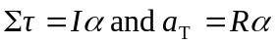
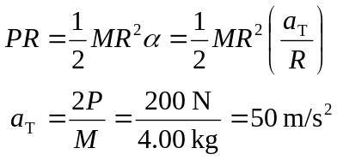
Distance the cable moves: 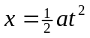
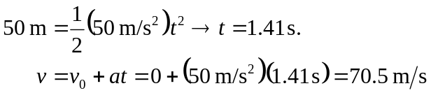

(b) For a hoop, 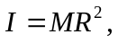which is twice as large as before, so 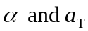 would be half as large. Therefore the time would be longer. For the speed, 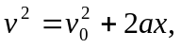in which x is the same, so would be smaller since a is smaller

